XYZ Company manufactures a specialty surgical glove for hospitals. The company’s fixed costs are $400,000 per month. The variable cost of production is $12.00 per pair of gloves. The gloves sell for $20.00 per pair. Use this information for questions 1 through 3.
1. The company has budgeted sales next month to be 38,000 pairs of gloves. What will be
the profit?
- -$96,000
- $50,000
- $96,000
- $304,000
- None of the above

Fixed cost | $4,00,000
Budgeted sales | 38000
The variable cost of production | $12.00
The gloves sells for | $20.00
Budgeted sales = 38000 * 12.00 | 456000
Actual sales = 38000 * 20.00 | 760000
Profit = budgeted sales - actual sales | 304000

2. The breakeven point for next month is (in pairs of gloves – round to nearest whole number if necessary)
- 20,000
- 33,333
- 50,000
- 57,000
- None of the above

Break even point in units = fixed cost / ( selling price - variable expenses)
Fixed cost | $4,00,000
Selling price | $20.00
variable expenses | $12.00
Break even point = $ 400000 / ( 20.00 - 12.00 )
Break even point = | 50000

3. The company has revised the budget for next month. It shows a profit goal of $200,000
for the month. The number of pairs of gloves that must be sold to meet this goal is
- 12,000
- 25,000
- 50,000
- 75,000
- None of the above
Profit goal | $2,00,000
Selling price | 20
Variable expense | 12
So the pair of shoes should be sold to meet goal = 200000 / (20.00 - 12.00)
Pair of shoes = | 25000

4 .Which is nota property of all Linear Programming problems?
A.An objective function
B.A goal to either maximize or minimize the objective function
C.Constraints
D.Multiple optimal solutions
E.Parameters

5.In linear programming, a feasible solution
A.Does not violate any of the constraints
B.Cannot include a value of zero for a decision variable
C.Is also the optimal solution
D.Will maximize profit or minimize cost
E.B, C, and D

6.In linear programming, the surplus variable for a constraint represents
A.Unused resource
B.Amount of resource needed
C.Shortage in available resource
D.Excess resource above what is required
E.Both B and C

7.In a linear programming model for profit, which of the following would result in no optimal solution?
A.The feasible solution area is unbounded below or to the left
B.The feasible solution area is unbounded above or to the right
C.The feasible solution area has more than four extreme points (corners)
D.The feasible solution area is too small
E.The non-negativity constraint is omitted

8.For a linear programming optimal solution, the sensitivity range for the value of a constraint quantity(the constraint quantity value is the right-hand-side value of the constraint)gives the range within which this value can vary without changing the
A.value of the objective function
B.feasible solution area
C.validity of the shadow price (dual value)
D.Both A and B
E.None of the above

9.Suppose that a linear programming model for profit has two decision variables and only two constraints other than the non-negativity constraint. We are told that both of these are ≤ constraints and that for each of them the slack variable is equal to zero. Then
A.Neither constraint contributes to determining the optimal solution point
B.One but not both of the constraints contributes to determining the optimal solution point
C.These two constraints determine the optimal solution point
D.There is no optimal solution point
E.There are multiple optimal solution points

10.In linear programming, the slack variable for a constraint represents
A.Unused resource
B.Unpurchased resource
C.Excess resource above what is required
D.Surplus resource
E.None of the above

11.In linear programming, the marginal value of one additional unit of a resource is the
A.Sunkcost
B.Constraint quantity
C.Slack
D.Surplus
E.Shadow price(dual value)

12.Sensitivity analysis in linear programming, as output on the QM Ranging report, is concerned with the
A.Coefficients of the objective function
B.Constraint quantities
C.Coefficients of the constraints
D.Addition of new decision variables
E.Both A and B

13.In the graphical solution of a linear programming problem to maximize profit, changing the value of the coefficient of a decision variable will
A.Move the profit line away from the origin
B.Move the profit line toward the origin
C.Change the slope of the profit line
D.Have no effect on the profit line
E.Either A or B depending on the sign of the change( + or -)

14.Suppose that for a linear programming model the slope of the profit line is exactly the same value as the slope of a constraint that is partly determining the feasible solution area. Then
A.There is one unique optimal solution
B.There are exactly two optimal solutions
C.There are multiple optimal solutions
D.There is no optimal solution
E.None of the above –this could never happen

15.In the graphical solution of a linear programming problem, increasing the value of the constraint quantity for a ≤ constraint will
A.Move the constraint line toward the origin
B.Move the constraint line away from the origin
C.Have no effect on the location of the constraint line
D.Either A or C depending on the initial value of the constraint quantity
E.Either B or C depending on the initial value of the constraint quantity

16.For a constraint to be in proper form for input to QM for Windows
A.There must be at least two decision variables in the constraint
B.A term on the left-hand side may combine two or more decision variables
C.The right-hand side may contain one or more decision variables
D.The right-hand side cannot be the value zero
E.The right-hand side must be a numeric value only

17.Which of the following constraints would be proper to use inQM for Windows?
A.6X1X2+ 9X3≤ 1420
B.14(𝑋1𝑋2)+ 239X3≤ 42,600
C.10X1+ X2 + 12X3≥ 450
D.All of the above
E.None of the above

18.Suppose that in a linear programming problem, the amount of product X1must be at least 65% of the combined amounts of X1andX2. Then the form of thisconstraint that is proper for use inQM is:
A.X1≥ 0.65(X1 + X2)
B.X1-0.65(X1 + X2) ≥ 0
C.X1-0.65X1 + X2≥ 0
D.0.35X1-0.65X2 ≥ 0
E.None of the above

The following is the mathematical model of a linear programming problem for profit:
Maximize Z = 2X1+ 3X2
subject to
4X1+ 9X2≤ 7210
X1+ 11X2≤ 110
17X1+ 9X2≤ 153
X1 , X2≥ 0
The constraint lines have been graphed below along with one example profit line (dashed). The decision variable X1is used as the X axis of the graph.Use this information for questions 19through 23.
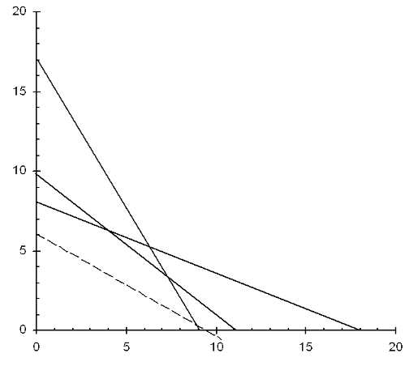

19. Which of the following gives the constraint line that cuts the X2 axis at X2= 17?
A.Z = 2X1+ 3X2
B.4X1+ 9X2≤ 72
C.10X1+ 11X2≤ 110
D.17X1+ 9X2≤ 153
E.X1 , X2≥ 0

20.The example profit line cuts the X1 axis at X1= 9. What is the example profit amount?
A.3
B.6
C.9
D.18 2*9=18
E.None of the above

21.The X, Y coordinate plane has four quadrants to its graph. Here is shown only the first quadrant(positive X, positive Y). Which of the following determines this?
A.Z = 2X1+ 3X2
B.4X1+ 9X2≤ 72
C.10X1+ 11X2≤ 110
D.17X1+ 9X2≤ 153
E.X1 , X2≥ 0

22.The optimal solution is X1= 4.3and X2 = 6.1. What is the maximum total profit?
A.8.6
B.10.4
C.18.3
D.26.9 Z=2*4.3+3*6.1=26.9
E.None of the above

23.At the optimal solution given in question 22 above, the value of the slack variable for the constraint 17X1+ 9X2≤ 153is
A.-25
B.0
C.25
D.14.4
E.None of the above

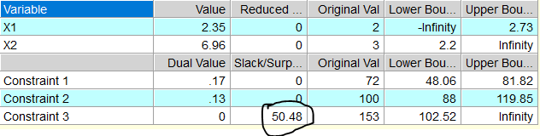

24.In the graphical solution of a linear programming problem to minimize cost, we seek to move the example line for the objective function
A.Away from the origin
B.Toward the origin
C.Parallel to the X1axis
D.Parallel to the X2axis
E.None of the above
25.Suppose a chemical company produces a liquid product by blending two other products that it purchases from an oil refinery. The blended product must meet specifications set by the customer. Total production is constrained by the company’s limited production capacity. The company wishes to find the minimum possible cost of production. Other than the non-negativity constraint, all the constraints are ≤. Then with regard to the graphical solution, we should
A.Proceed to locate the extreme point most distant from the origin
B.Proceed to locate the extreme point nearest the origin
C.Proceed to locate the optimal solution by moving the example line for the objective function away from the origin
D.Proceed to locate the optimal solution by moving the example line for the objective function toward the origin
E.Stop and reevaluate the problem because a mistake has probably been made

26.Suppose an optimal solution point is at the intersection of the constraint lines for these
two constraints:2X1+ 4X2≤30 and 4X1+ 2X2≤30
Then the optimal solution is:
A.X1= 0 and X2 = 7.5
B.X1= 15 and X2 = 0
C.X1= 5 and X2 = 4
D.X1= 4 and X2 = 5
E.None of the above

27.The cause of an unbounded linear programming model for profit is
A.Very large constraint quantities, resulting in a very large feasible solution area
B.Two or more constraint lines having the same value for their slopes
C.The line for the objective function having the same value for its slope as some constraint line
D.Incorrectly stating or not understanding the objective function
E.Incorrectly stating or not understanding the constraints

28.The optimal solution to a linear programming problem is: X1 = 12, X2 = 0, X3 = 23, and X4 = 0. Then the solutionmix (or “solution variable mix”) for this case is
A.X1, X2, X3, and X4
B.X1 and X3
C.X2 and X4
D.12 and 23
E.0 and 0

29.Givena linear programming optimal solution, if the value of the coefficient of a decision variable is changed but remains within its sensitivity range then
A.The value of the objective function will not change
B.The value of that decision variable will not change
C.The value of slack or surplus variables for all constraints will be zero
D.The dual value (shadow price) for every constraint will be zero
E.Both A and B

30.Which of the following problems would be better suited to integer solutions rather than continuous solutions?
A.Maximizing profit from mixing powders to create make-up products
B.Minimizing cost for mixing wine and fruit juice to create wine coolers
C.Maximizing profit for producing and selling laptop computers
D.Maximizing return on investment for a stock and bond portfolio
E.Both A and B

31.Which of the following problems would be a “Blend Example” as used in thetext?
A.Maximizing profit from mixing powders to create make-up products
B.Minimizing cost for mixing wine and fruit juice to create wine coolers
C.Maximizing profit for producing and selling laptop computers
D.Maximizing return on investment for a stock and bondportfolio
E.Both A and B

32.Suppose that in a linear programming solution that maximizes profit, the shadow price (dual value)for a constraint equals -300. Then
A.An increase to the value of the constraint quantity will increase profit
B.An increase to the value of the constraint quantity will decrease profit
C.A decrease to the value of the constraint quantity will increase profit
D.A decrease to the value of the constraint quantity will decrease profit
E.Both B and C

33.Suppose that in a linear programming model, all resources have been paid for. Then at the optimal solution the shadow price (dual value) represents
A.The minimum amount you would pay for one more unit of resource
B.The maximum amount you would pay for one more unit of resource
C.The exact amount you would pay for one more unit of resource
D.The cost of one more unit of resource
E.None of the

ABC, Inc. makes three types of computer monitors: Standard, Premium, and Deluxe. The profit per monitor for each is $150 for Standard, $190 for Premium, and $285 for Deluxe. For the coming month, the combined production of Standard monitors and Premium monitors must be at least 50,000 but must not exceed 70,000. The production of Deluxe monitors must be at least 30,000. Also, the production of Standard monitors must not exceed the production of Deluxe monitors plus 10,000. The company wishes to maximize its profit. Use as decision variables: X1= Standardmonitors,X2=Premium monitors, and X3=Deluxe monitors. We want to state the mathematical model for this case in proper form to run on QM for Windows.

Use this information for questions 34 through 38.(Commas are shown here for clarity. You would not enter them to QM.)

34.The objective function is
A.maximize Z = 150X1 + 190X2 + 285X3
B.minimize Z = 150X1 + 190X2 + 285X3
C.maximize Z = X1 + X2 + X3
D.minimize Z = X1 + X2 + X3
E.None of the above

35.Which constraint should be used for: “The production of Deluxe monitors must be at least 30,000.”
A.X3 ≤ 30,000
B.285X3 ≤ 30,000
C.X3 ≥ 30,000
D.285X3≥ 30,000
E.None of the above

36.Which constraint would be best to use for: “Also, the production of Standard monitors must not exceed the production of Deluxe monitors plus 10,000.”
A.X1 ≥ X3 + 10,000
B.X1 ≤ X3 + 10,000
C.X1 –X3 ≥ 10,000
D.150X1 –285X3 ≤10,000
E.X1 –X3 ≤ 10,000

37.Which constraint(s) would be best to use for this statement: “For the coming month, the combined production of Standard monitors and Premium monitors must be at least 50,000 but must not exceed 70,000.”
A.50,000 ≤ X1 + X2 ≤ 70,000
B.50,000 ≤ X1 + X2 and X1 + X2 ≤ 70,000
C.X1 + X2 ≥ 50,000 and X1 + X2 ≤ 70,000
D.50,000 ≥ X1 + X2 ≤ 70,000
E.Any of A, B, or C

38.The non-negativity constraint for this model would be: X1, X2, X3 ≥ 0. One part of the non-negativity constraint is redundant (unnecessary)in this case. Which part?(Choose only A, B or C).
A.X1 ≥ 0
B.X2 ≥ 0
C.X3 ≥0

39.Which of the following would require that a linear programming mathematical model be restated and solved again when using QM?
A.Adding a new decision variable
B.Adding a new constraint
C.Changing just one coefficient in a constraint
D.All of the above
E.A and B only

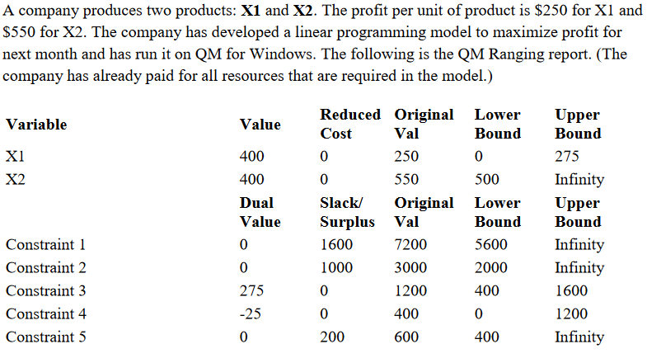

Use this Ranging report for questions 40through 50

40.The objective function is to maximize
A.Z = $400X1 + $400X2
B.Z = $250X1 + $550X2
C.Z = $275X1
D.Z = $500X2
E.None of the above

41.The optimal solution is to produce how many units of each product?
A.X1 = 275, X2 = 500
B.X1 = 0, X2 = 500
C.X1 = 250, X2 = 550
D.X1 = 400, X2 = 400
E.None of the above

42.At the optimal solution, the profit will be
A.$110,000
B.$200,000
C.$275,000
D.$320,000 250*400+550*400=320,000
E.None of the above

43.Which of the constraints determine the optimal solution?
A.Constraint 1 and Constraint 2
B.Constraint 3 and Constraint 4
C.Constraint 1, Constraint 2, and Constraint 5
D.Constraint 1 and Constraint 5
E.All of the constraints (1, 2, 3, 4, and 5)

Note: For questions 44 through 50 below, each change is from the original QM Ranging report (above) and is independent of any other question (that is, each question assumes that nothing else has changed).
44.Suppose that the profit for X2 increased from the current estimate of $550 per unit to $600. Then what will be the change in total maximum profit for next month?
A.No change
B.+$13,750
C.+$20,000250*400+600*400=340,000, 340,000-320,000=20,000
D.+$120,000
E.This Ranging report cannot be used to answer this question

45.Suppose that the profit for product X1 increased from the current estimate of $250 per unit to $300. Then what will be the change in total maximum profit for next month?
A.No change
B.+$13,750
C.+$20,000 300*400+550*400=340,000, 340,000-320,000=20,000
D.+$120,000
E.This Ranging report cannot be used to answer this question

46.Constraint 1 is a ≤constraint on the available labor hours for assembly required for the products. Suppose the company can obtain 1,000 more hours of labor for Constraint 1 at no additional cost. Should it do so? Why or why not?
A.Yes, the more available labor hours the better
B.Yes, the profit should go up
C.No, with the dual value (shadow price) equal to zero, the additional 1,000 labor hours contribute nothing to profit
D.No, the slack variable for Constraint 1 equals1,600 labor hours, meaning the company already has more assembly labor hours than it needs to achieve maximum profit.
E.Both C and D

47.Constraint 3 is a ≤ constraint on the available labor hours for testing required for the products. Suppose next month the company loses 100 of these labor hours because of illness among the workers. Then maximum profit next month would change by
A.-$40,000
B.-$27,500
C.Zero (no change)
D.+$27,500
E.+$40,000

48.Suppose the company can obtain 200 more labor hours of testing for Constraint 3 by paying $12,000. Then maximum profit next month would change by
A.-$67,000
B.-$55,000
C.Zero(no change)
D.+43,000
E.+$55,000

49.Constraint 4 reads: “The company entered a contract to provide 400 units of product X1 to a customer next month. Therefore production of X1 must be at least this much.”Suppose that the company produces 410 units of X1 next month. Then maximum profit next month would change by
A.-$10,250
B.-$250
C.Zero (no change)
D.+$250
E.+10,250

50.Supposethatthe customer who holds the contract for 400 units of product X1 offers to reduce the requirement to only 200 units in exchange for $2,000. If the company accepts this offer, then by how much will maximum profit change next month?
A.-$5,000
B.-$3,000
C.Zero (no change)
D.+$3,000
E.+$5,000

